Client Business Requirements
Program / Project Name MISYS-24: MAML Swaps Trade File

Program / Project No.: 0471
Document Version: 3.00 (2016-08-03)
Template Version: 1.01 (2013-02-28)
Prepared by: Clare Scully
Group: Client Change & Onboarding Europe
Function: Client Operations Initiatives
RBC Investor & Treasury Services™ is a global brand name and is part of Royal Bank of Canada. RBC Investor & Treasury Services is a specialist provider of asset servicing, custody, payments and treasury services for financial and other institutional investors worldwide. RBC Investor Services™ operates through two primary operating companies, RBC Investor Services Trust and RBC Investor Services Bank S.A., and their branches and affiliates.
In the UK, RBC Investor Services Trust operates through a branch authorized by the Prudential Regulation Authority and regulated by the Financial Conduct Authority and the Prudential Regulation Authority. The Dubai Branch of RBC Investor Services Trust is regulated by the Dubai Financial Services Authority.
In Australia, RBC Investor Services Trust is authorized to carry on financial services business by the Australian Securities and Investments Commission under the AFSL (Australian Financial Services Licence) number 295018.
In Singapore, RBC Investor Services Trust Singapore Limited (RISTS) is licensed by the Monetary Authority of Singapore (MAS) as a Licensed Trust Company under the Trust Companies Act and was approved by the MAS to act as a trustee of collective investment schemes authorized under S 286 of the Securities and Futures Act (SFA). RISTS is also a Capital Markets Services Licence Holder issued by the MAS under the SFA in connection with its activities of acting as a custodian.
In Hong Kong, RBC Investor Services Bank S.A. is a restricted license bank and is authorized to carry on certain banking business in Hong Kong by the Hong Kong Monetary Authority. RBC Investor Services Trust Hong Kong Limited is regulated by the Mandatory Provident Fund Schemes Authority as an approved trustee.
® / ™ Trademarks of Royal Bank of Canada. Used under licence.

Revision List
Ver. # | Date | Author | Description | Distribution
0.01 | 22/03/2016 | Clare Scully | Initial draft to kick off documentation process | Internal
0.02 | 23/03/2016 | Clare Scully | Updated following review by Finbarr O’Mahony | Internal
1.00 | 24/03/2016 | Clare Scully | No change from version 0.02 – 1.00 is marked as the “distributed” version shared with Mediolanum | All stakeholders
2.01 | 08/07/2016 | Shane McMunn | Changes made from version 1.00 following Mediolanum feedback | All Stakeholders
3.00 | 03/08/2016 | Clare Scully | Updated to capture final changes from Mediolanum and to remove now obselete information that is no longer relevant (e.g. old assumptions, etc) | All stakeholders

Table of Contents
The purpose of this document is to:
- Provide a vision for the expected outcome of the project.
- Act as a form of agreement, outlining project particulars and deliverables.
- Note: Requirements do not necessarily have to be collected and presented in this artefact format. If requirements software tools or alternate formats such as use cases are being used, then printed output of these formats can be substituted here.
Revision List 2
Table of Contents 1
1. Executive Summary 2
1.1. Project Identification 2
1.2. Related Documents 2
2. Project Description 3
2.1. Purpose 3
2.2. Critical Success Factors 3
2.3. Processes Impacted 3
2.4. Business Requirements Scope 3
3. Assumptions, Dependencies & Constraints 5
3.1. Dependencies 5
3.2. Constraints 5
3.3. Process Flows 6
3.4. Requirements 6
3.4.1. Functional Requirements 6
3.4.2. Non – Functional Requirements 12
4. Sign off Block 13
Reviewers 13
5. Appendix 1 – Modified Sample Report 14
6. Appendix 2 – Funds in Scope 14
7. Appendix 3 – Common Custody/Fund Accounting Fund Identifier 14
8. Appendix 4 – Trade Types in Scope 14

- Executive Summary
  - Project Identification
Project Name | Mediolanum Enhancements 2016 | Project No. | 0471
Program Name | As above | Program No. | As above
Project Start Date | 2016 | Project End Date | 2016
Project Manager | N/A | Group & Function | N/A
Program Manager | Kate Cullen | Group & Function | Associate Director, Client Change
Sponsor | Renato Moreschi | Group & Function | MD, Client Operations
  - Related Documents
Document Name / Description | Author | Purpose / Comments
Sample “to be” report | Clare Scully | Sample format and content of report to be used for the purposes of the reconciliation
Funds in Scope | RBC | Fund matrix
Common Fund Accounting & Custody Fund Identifier | RBC | List of all codes (concatenation of MF Code + Fund Manager ZCode)
Trade Types in Scope | RBC | RBC list of Trade Types in Scope for Report

- Project Description
  - Purpose
- Mediolanum Dublin will start to use new systems late 2016 which will result in a change to the way in which they communicate with RBC.
- These systems are FusionInvest (Risk & Portfolio Management system) and Intellimatch (Reconciliation system).
- Mediolanum have requested various information from RBC that will feed both systems:

Flow: RBC -> Mediolanum (High Level)
FusionInvest | Intellimatch
Custody & Fund Accounting trade file for Delegate Manager trades | Custody & Fund Accounting trade files for MAML trades
GFP confirmation of trading | Custody & Fund Accounting trade file for Delegate Manager trades
FX forwards initiated by RBC (e.g. COS) | Custody positions for all asset types (MAML and Delegate Managers)
Corporate Actions for MAML and Delegate Managers | Valuation for all security positions held on the portfolio (MAML and Delegate Managers)
Custody invoice file for MAML and Delegate Managers | Settled Cash and cash movement report (MAML and Delegate Managers)
 | GFP confirmation of MAML trading
 | Income (dividends) for MAML funds
 | Corporate Actions for MAML and Delegate Managers
 | Custody invoice file for MAML and Delegate Managers

- The purpose of this document is to provide the requirements for one sub-category of the category: Custody & Fund Accounting trade file for Delegate Manager trades. The sub-category is DIM Swaps trade file.
  - Critical Success Factors
- Successful loading and reconciliation of DIM swap trades in Fusion and Intellimatch
  - Processes Impacted
Process | Impact  (New/Deleted/Modified)
New report issued to Mediolanum on a daily basis | New
  - Business Requirements Scope
Business Requirements Scope
Creation of new report to capture swaps trade entries on the Fund Accounting system. Report must be sent to Mediolanum daily close of business
Scope Inclusions
- All Funds (Dublin and Luxembourg) where MAML is not the Fund Manager
- New report from RBC’s Fund Accounting data warehouse (Infocentre)
- Report should capture swaps trades. This includes partial closings of swaps, full unwinds and expiry/maturity trades
- Report must capture an OTC reference that MAML will provide the RBC OTC Middle Office team
- Report should only capture a trade once on the date it is processed to the NAV – except if that trade is subsequently cancelled. In this case the cancel must be reported on the file for the relevant NAV date.
- Report will be sent to Mediolanum daily, via SFTP. Mediolanum have requested RBC push to Mediolanum’s server.
Scope Exclusions
- Sourcing the data directly from the RBC OTC team and the OTC team’s system Arpson which was considered but discounted
- Having one trade file to cover both MAML and the Delegates .This is not possible – the Delegate file will be loaded to FusionInvest, but the MAML file is only for Intellimatch. Mediolanum cannot manage identifying which data to load to each system.

- Assumptions, Dependencies & Constraints
  - Dependencies
Description of Dependency | Impact if Not in Place | Recommended Actions /  Resolution / Comments
Resource – Mediolanum/Cronos to review docs and be available for UAT and queries | Delivery timeframe requested by Mediolanum may not be met | Schedule to be shared with all parties once available
Mediolanum want to avoid a situation where the cash element on a swap is included in both this file MISYS 24 and the Delegate Custody Cash File MISYS 18 causing a duplication on the cash accounts for the DIMS in Fusion.  Mediolanum will reach out to the Delegates to ask them to format their instruction to Custody in a way that will allow RBC to remove the cash entries from MISYS 18.  There is a possibility that if this approach is not successful, Mediolanum may ask RBC to remove the cash from this file MISYS 24. | Small change to requirements | Mediolanum to approach delegates and confirm output of discussions.
  - Constraints
Description of Constraint | Impact if Not in Place | Recommended Actions /  Resolution / Comments
Technical constraints may be identified as part of the IT detailed analysis | All requirements may not be able to be delivered | Results of detailed analysis to be shared with all stakeholders once available
RBC cannot split fees between Broker fees and Market fees as requested by Mediolanum. Fees are not broken down in this way in Multifonds.  Reviewing the swaps across the accounts, it is very rare for any commissions to be booked against the trades | N/A | Mediolanum to be aware

  - Process Flows
High level ‘to be’ flows are outlined below. Mediolanum system information has been included for illustrative purposes.
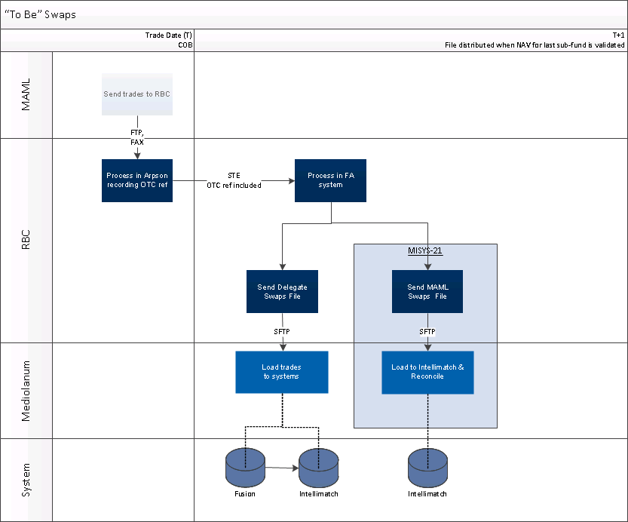
  - Requirements
    - Functional Requirements
General Requirements
Client Requirements
Product, Features & Options
Marketing & Sales
Communications
Credit & Risk
Other

ID | Requirement | Priority  1=high  5=low | Stability  High  Med  Low | Origin | Benefit
CR1 | File sent on a daily basis that captures swap trades received from the Delegate Managers (not MAML).  All swap trades must be captured:  - Initial Trade  - Partial or Full Unwind  - Expiry / Maturity  The file will be loaded to both Fusion and Intellimatch. | 1 | High | Mediolanum | To load trades to Intellimatch.

Operational Requirements
Operational Requirements
ID | Requirement | Priority  1=high  5=low | Stability  High  Med  Low | Origin | Benefit
OPR1 | Create a new report capturing the requirements set out in OPR2-OPR14.  A description of all fields in the report, along with a flag indicating which fields Mediolanum will use is provided in table 1.1. A sample ‘to be’ report is in Appendix 1. | 1 | High | Fund Accounting | To meet client requirement
OPR2 | Report must be in CSV format. Delimiter must be semi-colon. | 1 | High | Fund Accounting | To meet client requirement
OPR3 | Report must be sent to Mediolanum by FTP. Details to be confirmed at a later date.  RBC will push file to Mediolanum server. | 1 | High | Fund Accounting | To meet client requirement
OPR4 | Report must be sent daily at close of business once NAV is validated (T+1 6pm GMT). | 1 | High | Fund Accounting | To meet client requirement
OPR5 | Report must pick up all Mediolanum sub-funds across the Best Brands, Challenge, Portfolio, Specialities SIF and Gamax fund ranges.  Please refer to Appendix 2 for more information on funds | 1 | High | Fund Accounting | To meet client requirement
OPR6 | Report must capture only trades from Delengate Managers. This requires a filter where Fund Manager Actor Id is not equal to:  - Z8719429 (MAML – CASH)  The code above is stored as an “external ID” in RBC’s data warehouse Infocentre. | 1 | High | Fund Accounting | To meet client requirement
OPR7 | Report must be filtered to capture the RBC specific trade types referenced in Appendix 4. | 1 | High | Fund Accounting | To meet client requirement
OPR8 | Regardless of how the swap is captured in the Fund Accounting system, all elements linked to the trade must be reported on 1 line in the report.  i.e. if a swap has 2 legs, both legs must be captured on one line/row of the report.
OPR9 | Report must capture cancellations but Mediolanum don’t want to see the original & reversed  bookings if a trade is booked and reversed  on the same NAV.  - Reversals should only be reported if the original trade was booked on a previous NAV. | 1 | High | Fund Accounting | To meet client requirement
OPR10 | If there are no trades an empty report must be sent | 1 | High | Fund Accounting | To meet client requirement
OPR11 | Date format must be DD/MM/YYYY | 1 | High | Fund Accounting | To meet client requirement
OPR12 | If a re-generation is required (e.g. a Fund was not validated when the file was issued), only a delta between what was sent initially and the subsequent file is required. | 1 | High | Fund Accounting | To meet client requirement
OPR13 | The file must have an output filename:  DIM_TRADEFILE_SWAP_YYYYMMDDHHMMSS  Where the timestamp is generation time and not NAV date | 1 | High | Fund Accounting | To meet client requirement
OPR14 | The file must include field names | 1 | High | Fund Accounting | To meet client requirement

Table 1.1 sets out the field contents. That the fields will be populated differently depending on the type of swap captured. There are 3 categories/approaches:
- Equity Swaps
- All other swap purchases
- Unwinds/Maturities
The different approaches are detailed in the 4th and 5th columns of the table. A RBC technical definition of the difference between the trade types found in Appendix 4.

Table 1.1 Field description
ID | Field Name | Field Description | Populated  Equity Swap  (FU Mask*) | Populated  All Other Swaps  (IR Mask*) | Format
1 | Consolidated Fund Code | Umbrella Fund Code | Yes | Yes | Alpha Numeric
2 | Fund Code | Sub-fund Identifier | Yes | Yes | Alpha Numeric
3 | External Fund Identifier | Mediolanum “Common Identifier”.  Concatenation of Multifonds code and Fund Manager Actor ID. E.g. DB8815Z8997924 indicating the MGF manager on CH Italian Equity. | Yes | Yes | Alpha Numeric
4 | Fund Name | Sub-fund Name | Yes | Yes | Alpha Numeric
5 | Trade Date | Trade Date | Yes | Yes | DD/MM/YYYY
6 | Value Date | Value Date | Yes | Yes | DD/MM/YYYY
7 | Maturity Date | Maturity Date | Yes | Yes | DD/MM/YYYY
8 | Fusion Ref. | Fusion Identifier for OTCs only  RBC and Mediolanum will introduce a new process, described in detail in MISYS-12, that will result in this reference being available in RBC’s data warehouse in field:  Dea.N_External_Reference  It is only the reference after the “-” that must be captured on the report. | Yes | Yes | Alpha Numeric
9 | Trade Currency | Trade currency | Yes | No | Alpha
11 | Quantity | Quantity | Yes  If the trade is a sale, the value must be negative | No | Numeric (decimals as per FA system)
10 | Currency Payable Leg | Currency of Payable leg | No | Yes | Alpha
11 | Nominal Payable Leg | Notional payable amount | No | Yes  For an unwind (RBC trade type IR5,IR8*) the value must by a negative | Numeric (4 decimal places)
12 | Currency Receivable Leg | Currency of Receivable leg | No | Yes | Alpha
13 | Nominal Receivable Leg | Notional receivable amount | No | Yes  For an unwind (RBC trade type IR5,IR8*) the value must by a negative | Numeric (4 decimal places)
14 | Upfront Amount Flag | Flag to indicate whether the premium recorded is a payable or receivable amount. RBC will record value of ‘P’ or ‘R’ in this field. | No | Yes | Alpha
15 | Cost Price – Local Ccy | Upfront cost as outlined as recorded in Multifonds in local currency  Per unit in the case of an equity/FI Swap. | Yes | Yes | Numeric  (4 decimal places)
16 | Cost Price – Fund Ccy | Upfront cost as outlined as recorded in Multifonds in fund currency | Yes | Yes | Numeric  (4 decimal places)
17 | GTI Code | GTI Code | Yes | Yes | Numeric  (0 decimals)
18 | GTI Label | GTI Label / Description | Yes | Yes | Alpha
19 | RBC Contract Number | Concatenation of the RBC Service Code (IR, FU*) and the RBC Contract Number (e.g. IR4*) | Yes | Yes | Numeric  (0 decimals)
20 | Transaction Status Number | Status of the trade:  20: New  30: Reversal  40: Maturity / Note some maturities are booked with a value of 20 | Yes | Yes | Numeric  (0 decimals)
21 | BIC Code Broker | BIC Code of the broker | Yes | Yes | Alpha
22 | Premium | Same as field 15 | Yes | Yes – except on unwinds/maturities | Numeric  (4 decimal places)
23 | Gross Amount | Same as field 11 | Yes  If the trade is a sale, the value must be negative | Yes  If flag = “P” value must be negative | Numeric  (4 decimal places)
24 | Net Amount | Field 23 – any fees recorded | Yes  If the trade is a sale, the value must be negative | Yes  If flag = “P” value must be negative | Numeric  (4 decimal places)
25 | Fees | Broker and Market fees | Yes  If the trade is a sale, the value must be negative | Yes | Numeric  (4 decimal places)
* RBC system codes – refer to Appendix 4
Third Party Requirements
Third Party Requirements
Measurement Requirements
Measurement Requirements

    - Non – Functional Requirements
Non- Functional Requirements
Audit
Business Continuity
Data Retention
Documentation / Training
Fraud
Privacy
Volume Impact
Security
Availability
Hardware
Software
Reliability
Scalability
Performance
Interface
Infrastructure

- Sign off Block
Role | Name | Group & Function | Signature | Date
Project Manager | Noel Nolan | Mediolanum
Program Manager | Kate Cullen | RBC

Reviewers
Reviewers are acknowledging that they have reviewed the Business Requirements and are in agreement with the content.
Role | Name | Group & Function | Signature | Date
Mediolanum | Lizy di Vetta | Mediolanum
Mediolanum | John Burrows | Mediolanum
Cronos | Steve Lazouras | Cronos
Cronos | James Shillingford | Cronos
SME - Dublin | Michael Kosatka | Fund Accounting
SME – Luxembourg | Ludovic Francois | Fund Accounting
BSA | Delphine Tempesta | IT
IT PM | Sebastien Paulissen | IT

- Appendix 1 – Modified Sample Report
Sample file attached – this includes dummy data only. Line 1 is a partial unwind, Line 2 is a full unwind, Lines 3 and 4 is a new swap and Line 5 is a sale of an equity swap position.
The example is in excel, though the format will be semi-colon delimited csv.
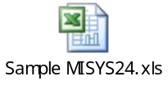

- Appendix 2 – Funds in Scope
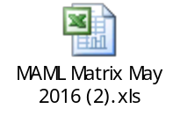
- Appendix 3 – Common Custody/Fund Accounting Fund Identifier
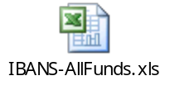

- Appendix 4 – Trade Types in Scope
Report must pick up the below trade types
ID | Service Code* | Trade Type** | Description | GTI Codes***
1 | IR | IR9 | New 2 legged swap | All
2 | IR | IR5 | Partial unwind of 2 legged swap | All
3 | IR | IR8 | Full unwind and maturity of 2 legged swap | All
4 | FU | 310 | Buy of a an equity swap | Only GTI codes in Appendix 4
5 | FU | 311 | Sale of an equity swap | Only GTI codes in Appendix 4
7 | BO | 202 | Sell of an equity/FI swap (rarely used) | Only GTI codes in Appendix 4

* RBC identifier of a screen on Multifonds used in the booking process
** Multifonds transaction type
*** Multifonds classifier of asset type

